VIRTUAL ENVIRONMENT

* **WHAT?**

The virtual environment is a copy of an existing version of Python with the option to inherit existing packages.

* **WHY?**

1.You can experiment with different combinations of packages without affecting your main installation

2. It is also useful when you need to work on a shared system and do not have permission to install packages as you will be able to install them in the virtual environment.

* **HOW?**

1. **Open a terminal**

Windows

Open the Windows Command Prompt (show path via Start menu and keyboard shortcuts)

Mac OS / Linux

Open the Terminal program. This is usually found under Utilities or Accessories.

1. **Setup the pip package manager**

* Check to see if your Python installation has pip. Enter the following in your terminal:

pip -h

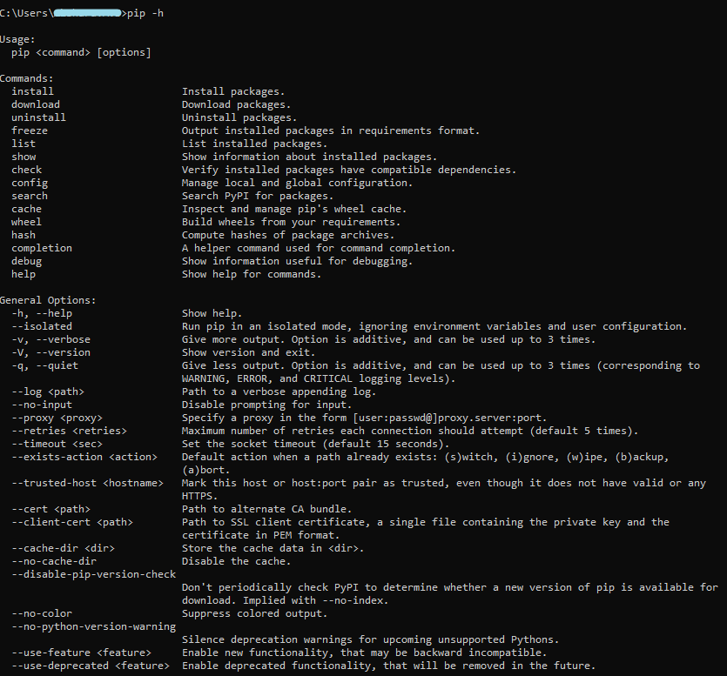

* If you see the help text for pip then you have pip installed, otherwise [download and install pip](https://pip.pypa.io/en/latest/installing.html)
* Update your pip to latest version by entering this code in your terminal (as per now version 21.0.1 is available):

python -m pip install --upgrade pip



1. **Install the virtualenv package**

* The virtualenv package is required to create virtual environments. You can install it with pip:

pip install virtualenv

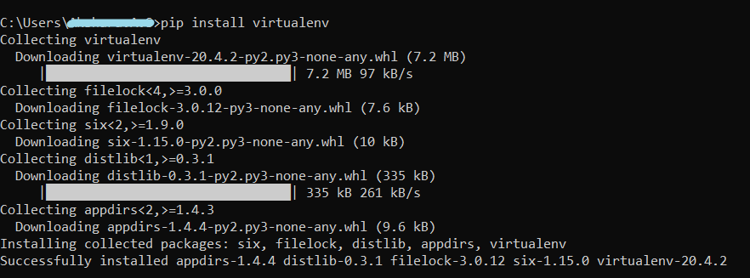

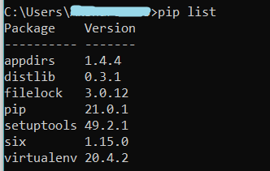

1. **Create the virtual environment**

* To create a virtual environment, you must specify a path. For example choose your desktop as a path.

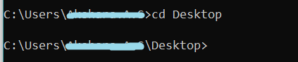

* Then type and click enter:

.

python -m venv <name_of_environment>



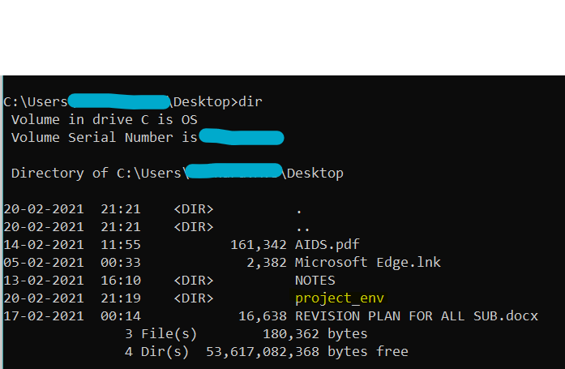

**5.Activation**

* To activate the virtual environment, type and click enter:

project_env\Scripts\activate.bat

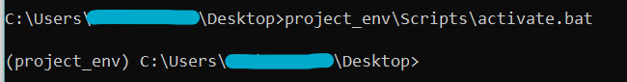

* Now, the virtual environment is activated. We can now work with it.

**6.Deactivation**

* To deactivate existing virtual environment, type and click enter:

deactivate



7.Deletion

* To delete it permanently, type and click enter:

rmdir <name_of_environment>

